DBMS - DML

1.Write a query to view the table structure.
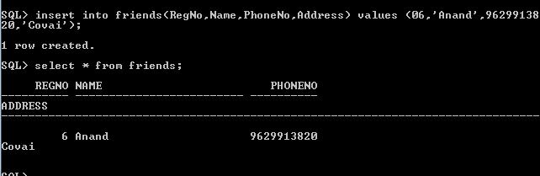

2. Write a query to insert the data into the table.

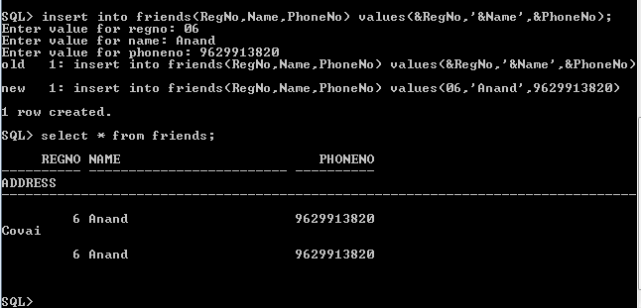

3. Write a query to insert the data into the table by dynamically getting input from user after query is executed.

4. Write a query to view the data from the table.

